Day86 - Task43 - Kubernetes(Part-07)

Task 1: Taint a Node and Schedule a Tolerant Pod Taint a node with special=true:NoSchedule. Create a pod with a toleration that matches the taint, allowing it to be scheduled on the tainted node.

Step 1: Taint the node
- Use worker-1: kubectl taint nodes worker-1 special=true:NoSchedule
- Verify: kubectl describe node worker-1 | grep -i taint
What does NoSchedule mean?
- A normal Pod that does not tolerate this taint will not be scheduled onto worker-1.

Step 2: Create a Pod with a toleration
- Create tolerant-pod.yaml:
apiVersion: v1
kind: Pod
metadata:
name: tolerant-pod
spec:
tolerations:
- key: "special"
operator: "Equal"
value: "true"
effect: "NoSchedule"

containers:
- name: nginx
image: nginx:1.27
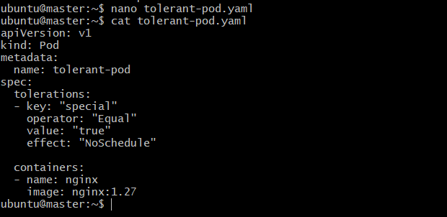
- Apply: kubectl apply -f tolerant-pod.yaml
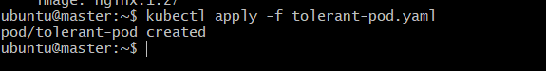
- Check: kubectl get pod tolerant-pod -o wide
- The Pod is now allowed to run on worker-1.
- Verify the toleration: kubectl describe pod tolerant-pod
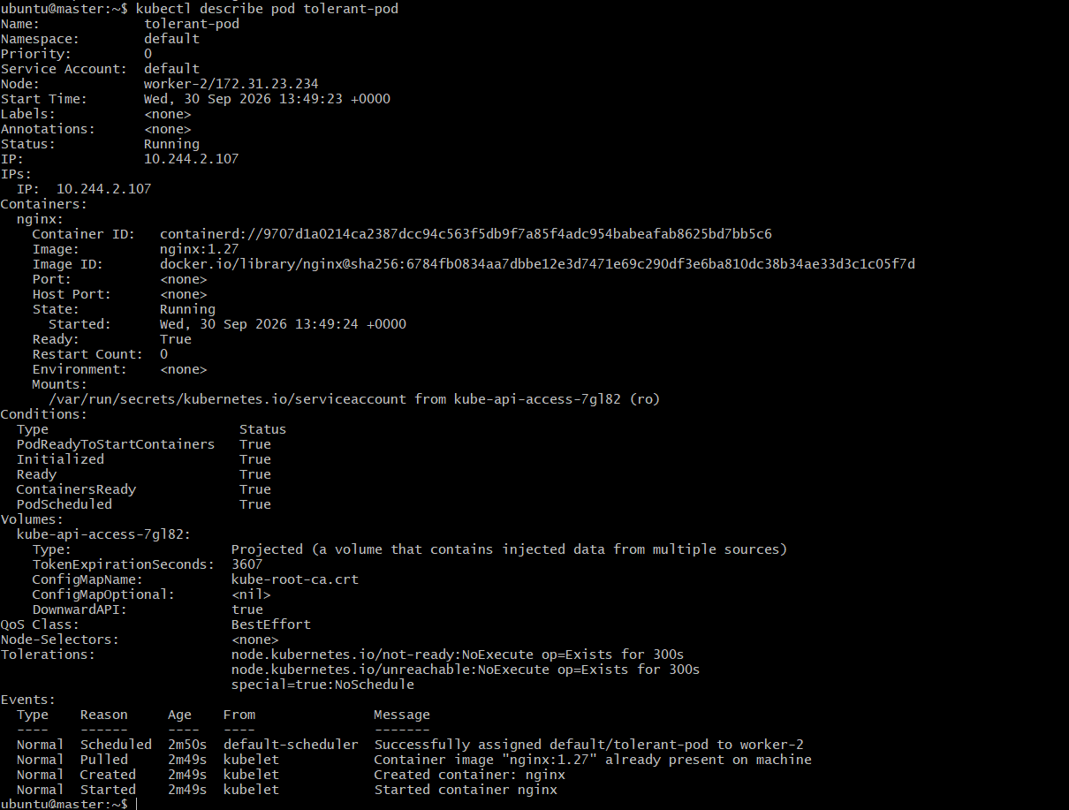

Task 2: Use NodeSelector to Schedule a Pod on a Specific Node Label a node with env=dev. Create a pod with a nodeSelector that schedules it only on the node labeled env=dev.

Step 1: Label worker-1
- kubectl label nodes worker-1 env=dev
- Verify: kubectl get nodes --show-labels

Step 2: Create Pod with nodeSelector
- Create node-selector-pod.yaml:
apiVersion: v1
kind: Pod
metadata:
name: node-selector-pod
spec:
nodeSelector:
env: dev

containers:
- name: nginx
image: nginx:1.27

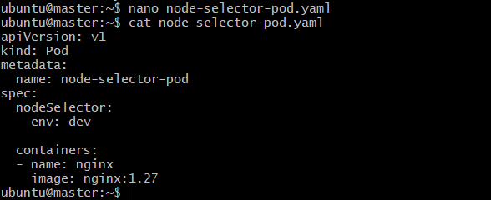
- Apply: kubectl apply -f node-selector-pod.yaml

- Verify: kubectl get pod node-selector-pod -o wide

Task 3: Use Node Affinity with Soft Scheduling Label a node with env=test. Create a pod with PreferredDuringSchedulingIgnoredDuringExecution node affinity, preferring to schedule it on a node labeled env=test. Remove the label and verify the pod continues to run

Step 1: Label worker-2
- kubectl label nodes worker-2 env=test
- Verify: kubectl get node worker-2 --show-labels

Step 2: Create Pod with preferred affinity
- Create preferred-affinity-pod.yaml:
apiVersion: v1
kind: Pod
metadata:
name: preferred-affinity-pod
spec:
affinity:
nodeAffinity:
preferredDuringSchedulingIgnoredDuringExecution:
- weight: 100
preference:
matchExpressions:
- key: env
operator: In
values:
- test

containers:
- name: nginx
image: nginx:1.27

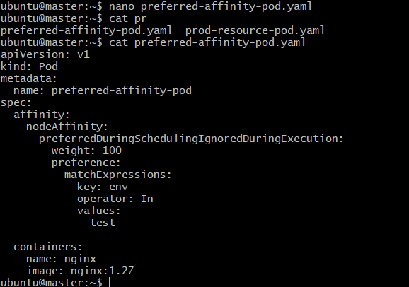
- Apply: kubectl apply -f preferred-affinity-pod.yaml
- Check: kubectl get pod preferred-affinity-pod -o wide
- Kubernetes will prefer worker-2, because it has: env=test
- But it is not mandatory.

Step 3: Remove the label
- kubectl label nodes worker-2 env-
- Verify: kubectl get node worker-2 --show-labels
Step 4: Check the Pod
- kubectl get pod preferred-affinity-pod -o wide
- The existing Pod continues to run.
- The name tells us the behavior:
  - PreferredDuringSchedulingIgnoredDuringExecution
  - PreferredDuringScheduling
- Kubernetes prefers the matching node when scheduling. IgnoredDuringExecution
- After the Pod is already running, Kubernetes does not evict it just because the node no longer matches the affinity rule.

Task 4: Implement Node Affinity with Hard Scheduling Create a pod with RequiredDuringSchedulingIgnoredDuringExecution node affinity, ensuring it will only be scheduled on a node labeled env=prod. Verify the pod cannot be scheduled if no node has the env=prod label.

Step 1: Make sure no node has env=prod
- Check: kubectl get nodes --show-labels
- If env=prod is not present, continue.

Step 2: Create Pod
- Create required-affinity-pod.yaml:
apiVersion: v1
kind: Pod
metadata:
name: required-affinity-pod
spec:
affinity:
nodeAffinity:
requiredDuringSchedulingIgnoredDuringExecution:
nodeSelectorTerms:
- matchExpressions:
- key: env
operator: In
values:
- prod

containers:
- name: nginx
image: nginx:1.27

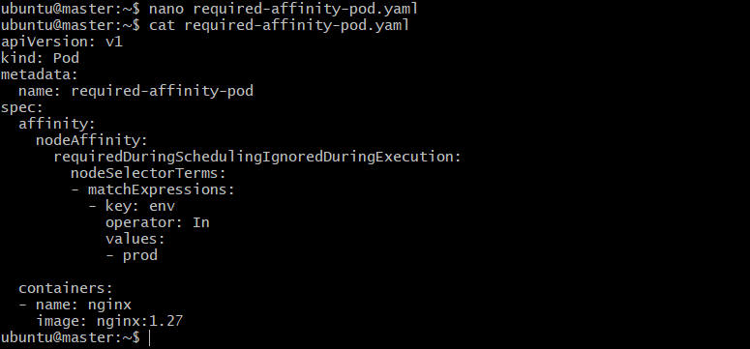
- Apply: kubectl apply -f required-affinity-pod.yaml
- Check: kubectl get pod required-affinity-pod -o wide

Step 3: Check why it is Pending
- kubectl describe pod required-affinity-pod
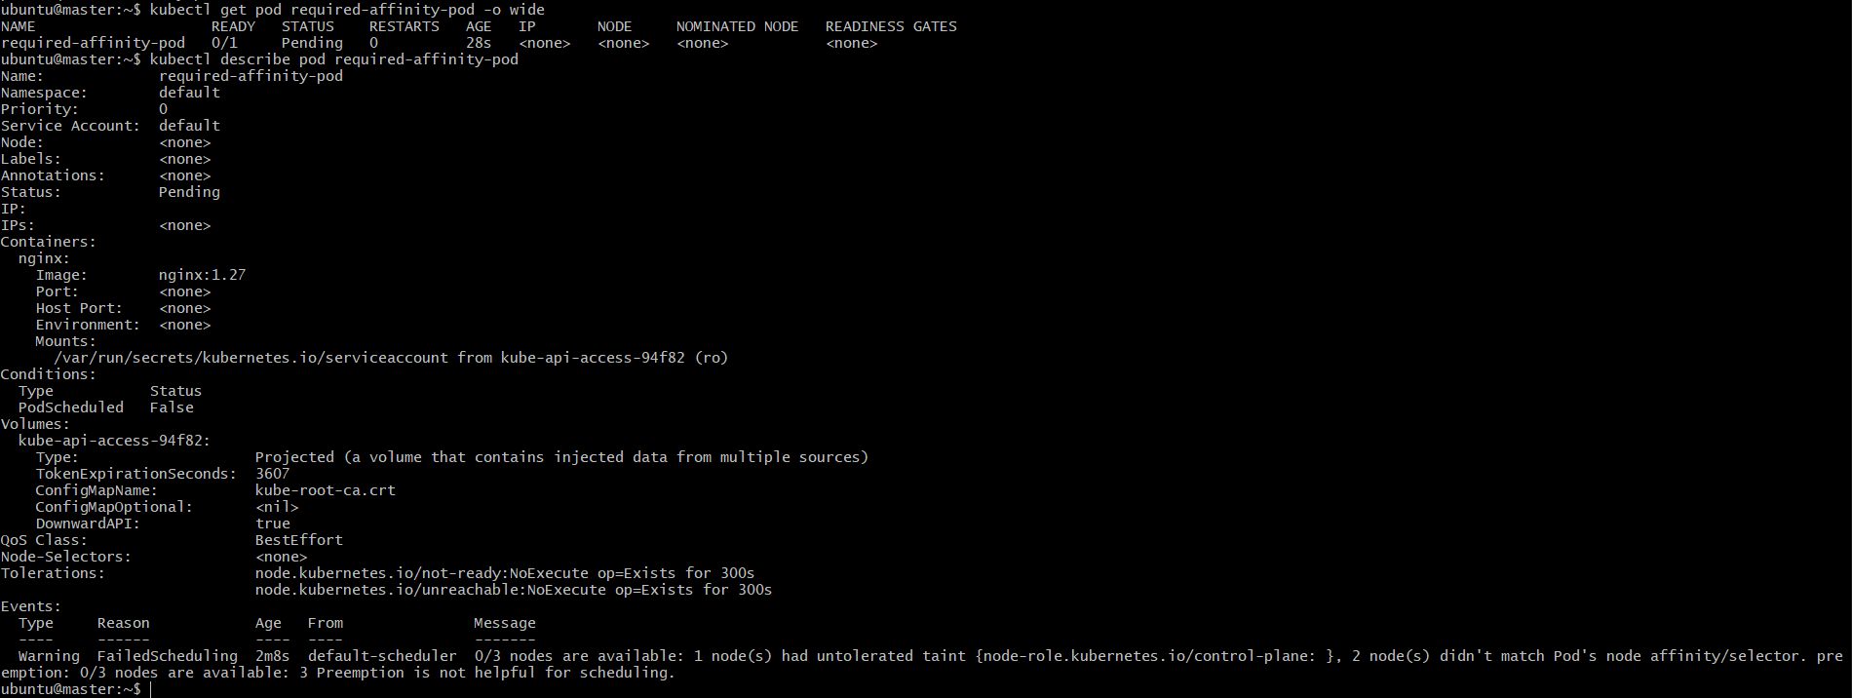

Step 4: Add the required label
- Label worker-1: kubectl label nodes worker-1 env=prod –overwrite
- Verify: kubectl get nodes --show-labels
- Now Kubernetes can schedule the Pending Pod.
- Check: kubectl get pod required-affinity-pod -o wide

Task 5: Taint a Node and Use NoExecute with Toleration Seconds Taint a node with special=true:NoExecute. Create a pod with a tolerationSeconds field (e.g., 60 seconds) and observe it gets evicted after 60 seconds on the tainted node.

Step 1: Taint worker-1
- kubectl taint nodes worker-1 special=true:NoExecute
- Verify: kubectl describe node worker-1 | grep -i taint

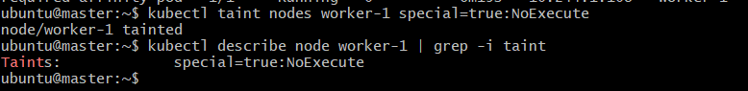
Step 2: Create a Pod with 60-second toleration
- Create noexecute-pod.yaml:
apiVersion: v1
kind: Pod
metadata:
name: noexecute-pod
spec:
tolerations:
- key: "special"
operator: "Equal"
value: "true"
effect: "NoExecute"
tolerationSeconds: 60

containers:
- name: nginx
image: nginx:1.27

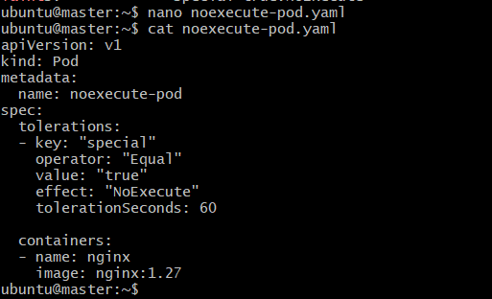
- Apply: kubectl apply -f noexecute-pod.yaml
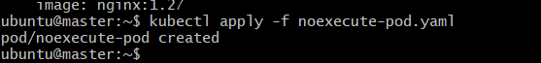

Step 3: Make sure the Pod is on worker-1
- Because the Pod has no node selector, Kubernetes may choose another node.
- Check: kubectl get pod noexecute-pod -o wide

- If it is not on worker-1, the eviction demonstration will not behave as intended.
- For a controlled lab, you can add:
nodeSelector:
kubernetes.io/hostname: worker-1
So the complete Pod becomes:
apiVersion: v1
kind: Pod
metadata:
name: noexecute-pod
spec:
nodeSelector:
kubernetes.io/hostname: worker-1

tolerations:
- key: "special"
operator: "Equal"
value: "true"
effect: "NoExecute"
tolerationSeconds: 60

containers:
- name: nginx
image: nginx:1.27

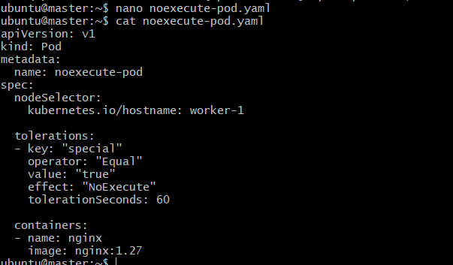
- Then apply: kubectl apply -f noexecute-pod.yaml

Step 4: Observe the Pod
- Immediately: kubectl get pod noexecute-pod -o wide
- Wait approximately 60 seconds and check: kubectl get pod noexecute-pod -o wide
- The Pod should be evicted/terminated because its toleration period expired.
- You can also watch: kubectl get pod noexecute-pod -w
